Jacob Nancarrow-Koprowski
Phone # 360-525-7555 Email Address: Koprowskijacob@gmail.com Website
TELEVISION PRODUCER

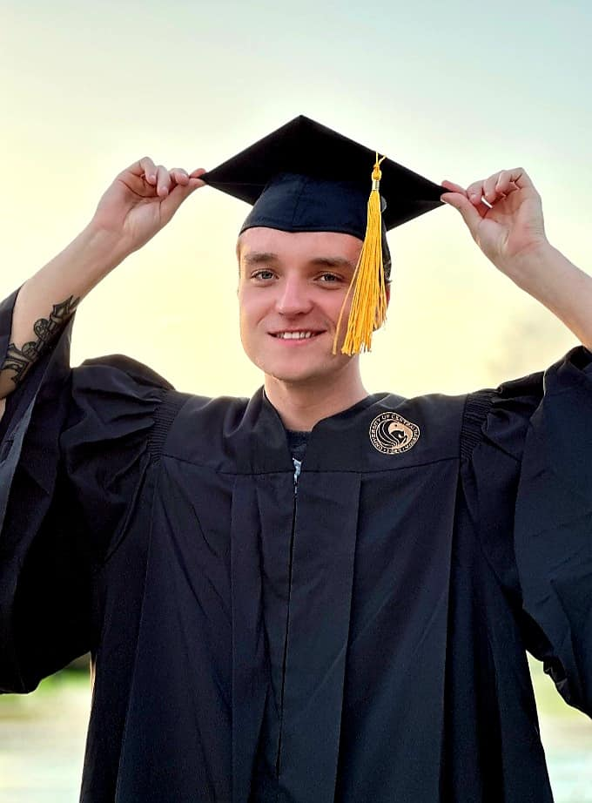 | PROFILE  Television Producer and Programmer, utilizing my 4+ years of hands-on experience from camera operations.  - Recognized for production performance and excellence in Tri caster Operation.  - Highly experienced associate known for exemplary team building and project oversight skills.  - Gifted at working with all types of personalities.  - Organized, adaptable and knowledgeable in camera work. Drive individual loyalty by providing friendly and skilled support. Goal-Oriented individual.
SKILLS  Multi-tasking strength  Content creation  Adobe Premiere CC cert.  Photoshop CC certified  Relationship Building | EXPERIENCE  Technical Intern- WUCF Orlando Florida  1/2022-6/2022  - Worked closely with shift manager to solve problems and handle production concerns.  - Worked as director for promoting a product for an informercial.  - Operated the soundboard at acceptable volume levels to make sure everyone in front of the camera is heard.  - Precise in cutting audio when the camera transitions to not raise background issues.  - Managed technical director for some days. Managed Tri caster system for preview and program. Memorizes the criteria each week.  Sales Associate- Lowe’s Home Improvement Oviedo Florida  4/2020-Current  - Helped customers locate products and checked store system for merchandise at other sites.  - Answered customer questions regarding sizing, accessories, and proper care for merchandise. Worked alongside retail representatives to enhance product presentations and advertising collateral.  - Achieved perfect attendance and on-time record. Maintained customer satisfaction with quick and professional handling of product returns.  - Engaged with customers to effectively build rapport and lasting relationships. Managed a Forklift/narrow aisle

EDUCATION

University of Central Florida

2019-2023
Bachelors in television production

- Member of Kappa Upsilon Chi
- Dean’s List Spring 2020, 2021, 2022
- Member of Omicron Delta Kappa Leadership Honor Society

